INDIAN SCHOOL AL WADI AL KABIR
DEPARTMENT OF SOCIAL SCIENCE
MID TERM ASSESSMENT: 2023-24
Date: 19/09/23 Answer key Time Allowed :2½hour
Class: VIII Max. Marks: 80
General Instructions: -
1. Ensure that you have written your name and roll number correctly.
2. This Question paper has three parts, Section A (History)B (Civics) C (Geography).
3. All questions are compulsory.
4. Detach the map from the question paper and tie it along with your answer script.
5. All the answers must be correctly numbered as in the question paper in the Answer sheet
provided.

 | SECTION - A (HISTORY) 40 Marks
I | Choose the correct answer: - | 5 marks
1 | Who was the first Governor general in India?  a) Warren Hastings b) Ripon c) Harding d) Lytton | 1 mark
2 | Census were held at the interval of every  a) five years b) four years c) seven years d) ten years | 1 mark
3 | The British thought ______ were important for the effective administration  a) Census b) Surveys c) Achieves d) Official records | 1 mark
4 | Gomasthas were the agents of the  a) Planters (b) Industries (c) Factories (d) Farmers | 1 mark
5 | Where did the Sepoy mutiny primarily begin in 1857?  (a)Meerut(b)Kanpur(c)Jhansi (d)None of these. | 1 mark
II | Fill in the blanks: - | 3 marks
6 | Bigha was the unit of Land measurement in Bengal. | 1 mark
7 | History is about finding out how things were in the past and how things have been changed. | 1 mark
8 | Nana Sahib was the adopted son of Peshwa Baji Rao II. | 1 mark
III | Match the following: -  Column A Column B  9 Governor General A Birjis Qadr  10 Ryoti B Village  11 Begum Hazrat Mahal C Farmer  12 Mahal D Lord Dalhousie  E Cultivation on ryot’s lands  Ans: 9-D; 10-E; 11-A; 12-B | 4 marks
IV | Answer the following: - | 6 marks
13 | What is the problem with the periodisation of Indian history that James Mill offers? [any 2 points]  James Mill divided Indian history into three periods – Hindu, Muslim and British. This periodisation has its own problem.  - It is difficult to refer to any period of history as ‘Hindu’ or ‘Muslim’ because a variety of faiths existed simultaneously in these periods.  - It is also not justified to characterise an age through the religion of the rulers of the time. What it suggests is that the lives and practices of others do not really matter.  - It is worth-mentioning that even rulers in ancient India did not all share the same faith. | 2 marks
14 | Give two problems which arose with the new Munro system of fixing revenue.  The two problems which arose with the new Munro system of fixing revenue were:  - Driven by the desire to increase the income from land, revenue officials fixed too high revenue demand.  - Peasants were unable to pay, ryots fled the countryside and villages became deserted in many regions. | 2 marks
15 | How did the last Mughal emperor live in his last years of his life?  - The last Mughal emperor lived a very pathetic life during the last years of his life.  - He was tried in court and sentenced to life imprisonment.  - He and his wife were sent to prison in Rangoon.  - He died there after four years. (Any 2 points) | 2 marks
V | Answer in brief: - | 9 marks
16 | Observe the following picture and answer the following  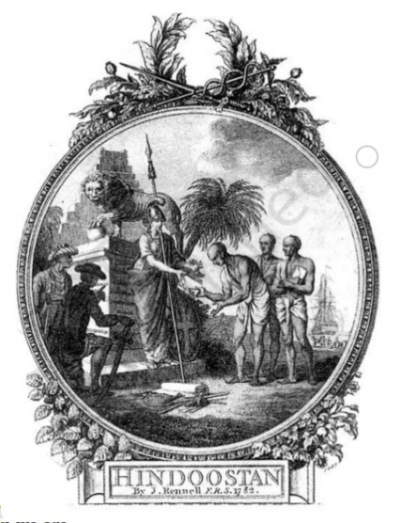  a). What does the above picture try to suggest? (2 marks)  An. The picture tries to suggest that Indians willingly gave over their ancient texts scriptures (shashtra) to Britannia, the symbol of British power, as if asking her to become the protector of Indian culture.  b). Explain how this image projects an imperial perception. (1 mark)  An. This image clearly depicts the imperial superiority. The image of the lion symbolizes superior power.  c). What does the term ‘imperial perception’ mean?  An. The influence and power that the British had over our country in the late Ottoman period. / Power or control of one country over another country. | 3 marks
17 | What were the drawbacks of ‘Nij’ cultivation?  Ans: The drawbacks of ‘Nij’ cultivation are:  - The planters found it difficult to expand the area under Nij cultivation.  - Labour force was not easily available.  - Nij cultivation on a large scale also required many ploughs and bullocks investing on purchase and maintenance of ploughs was a big problem. | 3 marks
18 | What were the measures taken by the British to reform Indian Society?  The British introduced many reforms in India:  ●They passed laws to ban the practice of sati.  ●They encouraged the remarriage of widows.  ●They promoted the English language education.  ●They allowed the Christian Missionaries to function freely in its domain.  ●In 1850, a new law was passed to make conversion to Christianity easier  [any 3 points] | 3 marks
VI | Read the passage carefully and answer the questions that follow: - | 3 marks
19 | The British had not expected this to happen. They thought the disturbance  caused by the issue of the cartridges would die down. But Bahadur Shah  Zafar’s decision to bless the rebellion changed the entire situation  dramatically. Often when people see an alternative possibility they feel  inspired and enthused. It gives them the courage, hope and confidence to  act  - What did the British think regarding the disturbance caused by the issue of cartridges?  A: The British had not expected the disturbance caused by the issue of cartridges to escalate and thought it would die down.  - What was the impact of Bahadur Shah Zafar's decision to bless the rebellion?  A: Bahadur Shah Zafar's decision to bless the rebellion dramatically changed the entire situation as it inspired and gave them the courage, hope, and confidence to act.  - What demand did the ageing emperor have to accept?  A: The ageing emperor had to accept the demand to organize a confederacy of Indian states to fight the British. | 1 mark  1 mark  1 mark
VII | Answer in detail: - | 5 Marks
20 | Describe the main features of the Permanent Settlement.  - The East India Company introduced the Permanent Settlement in 1793.  - By the terms of the settlement, the rajas and talukdars were recognized as zamindars.  - They were asked to collect rent from the peasants and pay revenue to the Company.  - The amount to be paid was fixed permanently and it was not to be increased ever in future.  - The purpose of fixing the amount was to ensure a regular flow of revenue into the Company’s coffers and at the same time, to encourage the zamindars to invest in improving the land.  - Since the revenue demand of the state would not be increased, the zamindars paid the Company only the fixed revenue and kept the surplus production from the land.  OR  What were the main features of the ‘Ryoti’ system of cultivation?  Ans: The main features of the ‘Ryoti’ system of cultivation are:  - Under the Ryoti system, the planters forced the ryots or peasants to sign a contract.  - The village headman was also forced to sign an agreement on behalf of the ryots.  - The peasants received a loan from the planters to cultivate their land. Due to this the peasants were forced to cultivate indigo in 25% of their land.  - The peasants received seeds and ploughs for cultivation from the Planters.  - They had to cultivate the crop and harvest it. The harvested indigo crop had to be given to the planters. | 5marks
VIII | On the given outline Map of India, Identify and name the territories marked A, B, C, D and E | 5 marks
 | 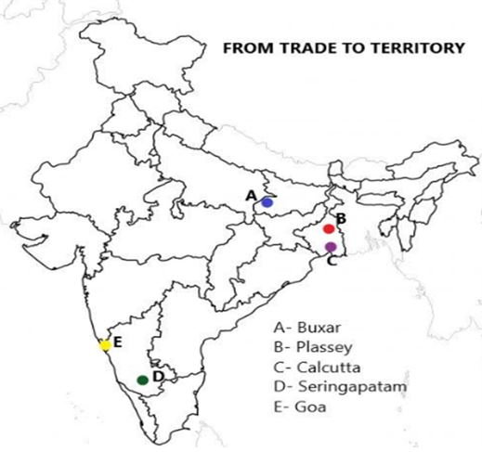
 | SECTION - B (CIVICS) 20 Marks
IX | Choose the correct answer: - | 5 marks
21 | _____________ refers to the existence of more than one level of government in a country.  - Secularism b) Federalism 3) Unionism d) none of these | 1 mark
22 | Who was the President of the Constituent Assembly of India?  a) Dr. Rajendra Prasad. b) Jawaharlal Nehru. c) Dr. John Mathai. d) Shri Jagjivan Ram | 1 mark
23 | What was the demand of the Indian National Congress in 1935?  a) Constituent Assembly b) Constitution Assembly c) Conventional  Assembly d) none of these | 1 mark
24 | Which is an important way to control the executive in Parliament?  a) Assembly b) Zero-hour c) Question hour d) none of these | 1 mark
25 | Representatives to the Indian Parliament are chosen by the  a) People b) Prime Minister c) President d) None of these | 1 mark
X | Fill in the blanks: - | 3 marks
26 | A written document in which we find the rules formulated through conscience is called as _______________  Constitution. | 1 mark
27 | ______________ protects the Fundamental Rights of the people in India.  Constitution. | 1 mark
28 | All the representatives in the Parliament together control and guide the government. | 1 mark
XI | Answer the following: - | 4 marks
29 | What would happen if there were no restrictions on the power of elected representatives?  - If there were no restrictions on the power of the elected representatives then there would be chaos, confusion and anarchy.  The elected representatives may misuse the powers given to them. The Constitution provides safeguards against the misuse of power by the political leaders. | 2 marks
30 | Why Laws are important in a country?  Ans: Laws are essential to:  • Prevent people from engaging in a variety of unjust social practices.  • Prohibit the practise of untouchability, which has caused millions of people to suffer.  • Ensure equality among Indian citizens.  • Provide methods to govern activities in order to get the most out of all types of resources. | 2 marks
XII | Answer in brief: - | 3 marks
31 | Why do you think our national movement supported the idea that all adults should have a right to vote?  - Under colonial rule, people were fearful and they were severely punished for criticizing the government’s policies.  - The nationalist realized the injustice of the colonial rule and felt that the people have a right to participate in government decision making.  - Hence, they supported the idea of universal adult franchise which provides the right to vote. | 3 marks
XIII | Answer in detail: - | 5 marks
32 | How is the national government formed?  - After the Lok Sabha elections, a list of MPs from each political party is compiled.  - A political party must have a majority of elected MPs in order to create the government.  - The Lok Sabha has 545 members, 543 of whom are elected and 2 of whom are nominated.  - To have a majority, a party must have at least half the number of members, or 272 or more.  - All political parties in Parliament that oppose the dominant party or coalition comprise the opposition. The largest of these parties is referred to as the Opposition party. | 5 marks
 | SECTION - C (GEOGRAPHY) 20 Marks
XIV | Choose the correct answer: - | 3 marks
1 | Which one of the following is a human-made resource?  (a) Medicines to treat cancer (b) spring water (c) tropical forests (d) None of these | 1 mark
2 | High speed winds, solar energy, bio waste etc. were all considered as potential sources of energy in the past, but today they are all examples of -  a) Non-Renewable Resources b) ubiquitous Resources c) Actual Resources d) Localized Resources | 1 mark
3 | Coal is an example of -  a) Renewable resources b) Non-renewable resources c) Solar power d) Human resources | 1 mark
XV | Match the following: -  Column A Column B  4 Resource A Renewable resource  5 Tundra vegetation B Coastal and dry regions  6 Windmill C Utility  7 Shelter belts D Kaziranga park  E Mosses and Lichens  Ans: 4-C; 5-E; 6-A; 7-B | 4 marks
XVI | Answer the following: - | 2 marks
8 | What is a “resource”? How resources are generally classified?  Any natural or human wealth that can be used for satisfying human needs is called a “resource”.  Resources are generally classified into different groups depending upon their level of development and use, origin, stock and distribution. | 2 marks
XVII | Answer in brief: - | 6 marks
9 | “Human resources are an important entity”. Give reasons.  Ans: Human resources refer to people and their contributions. Human resources are important as they are skilled to be able to make the best use of nature in order to enhance the existing resources and also create more resources using the knowledge and technology that they possess. Hence, human resources are considered highly significant. | 3 marks
10 | Draw and label the diagram of Soil Profile.  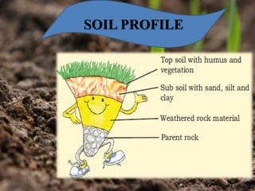 | 3 marks
XVIII | Answer in detail: - | 5 marks
11 | Define ‘soil’. Suggest some measure to make the soil fertile?  - The thin layer of grainy substance covering the surface of the earth is called soil.  - It is closely linked to land. Landforms determine the type of soil.  - Soil is made up of organic matter, minerals and weathered rocks found on the earth.  - This happens through the process of weathering.  - The right mix of minerals and organic matter make the soil fertile. | 5 marks

